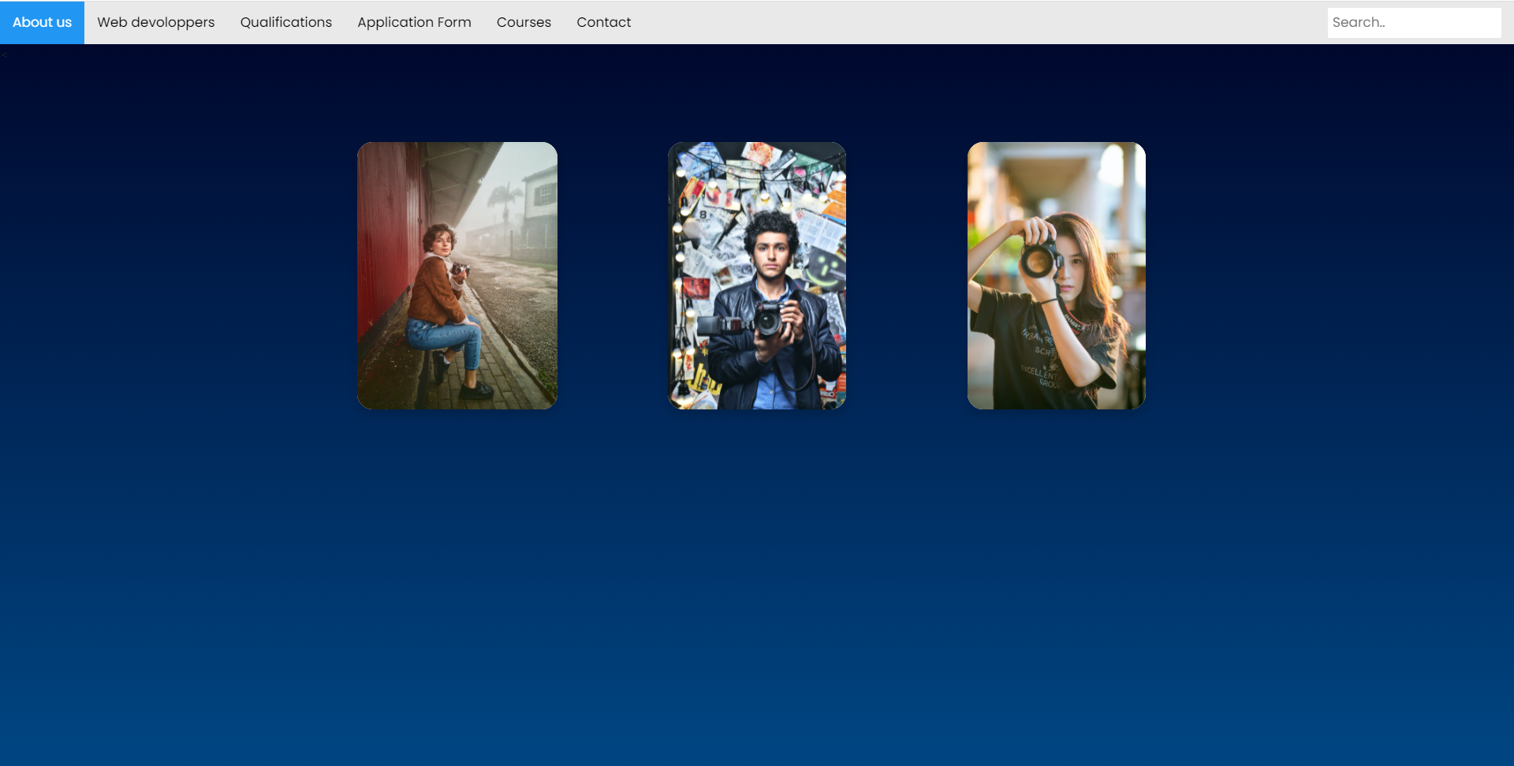

No information about the employee, there is only pics.

No title

The images are related to the company content

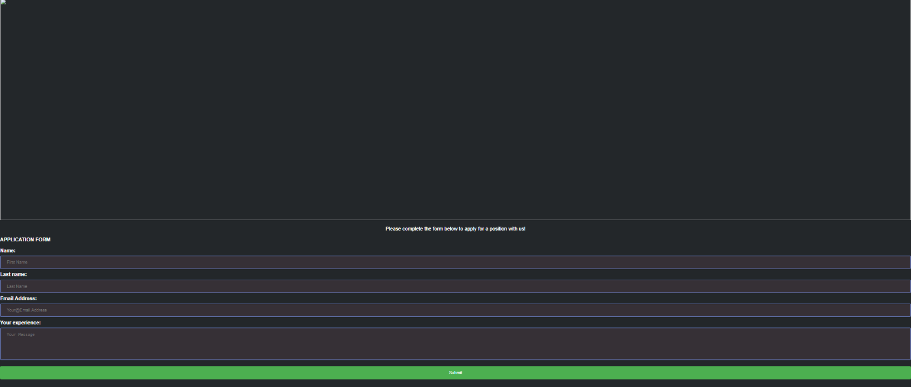**before improvement Form:**

**The picture is broken,**

**No option to upload CV**

**No header**

**No buttons**

**Too dark, not readable**

**Empty space on the top**

**About Us page:**

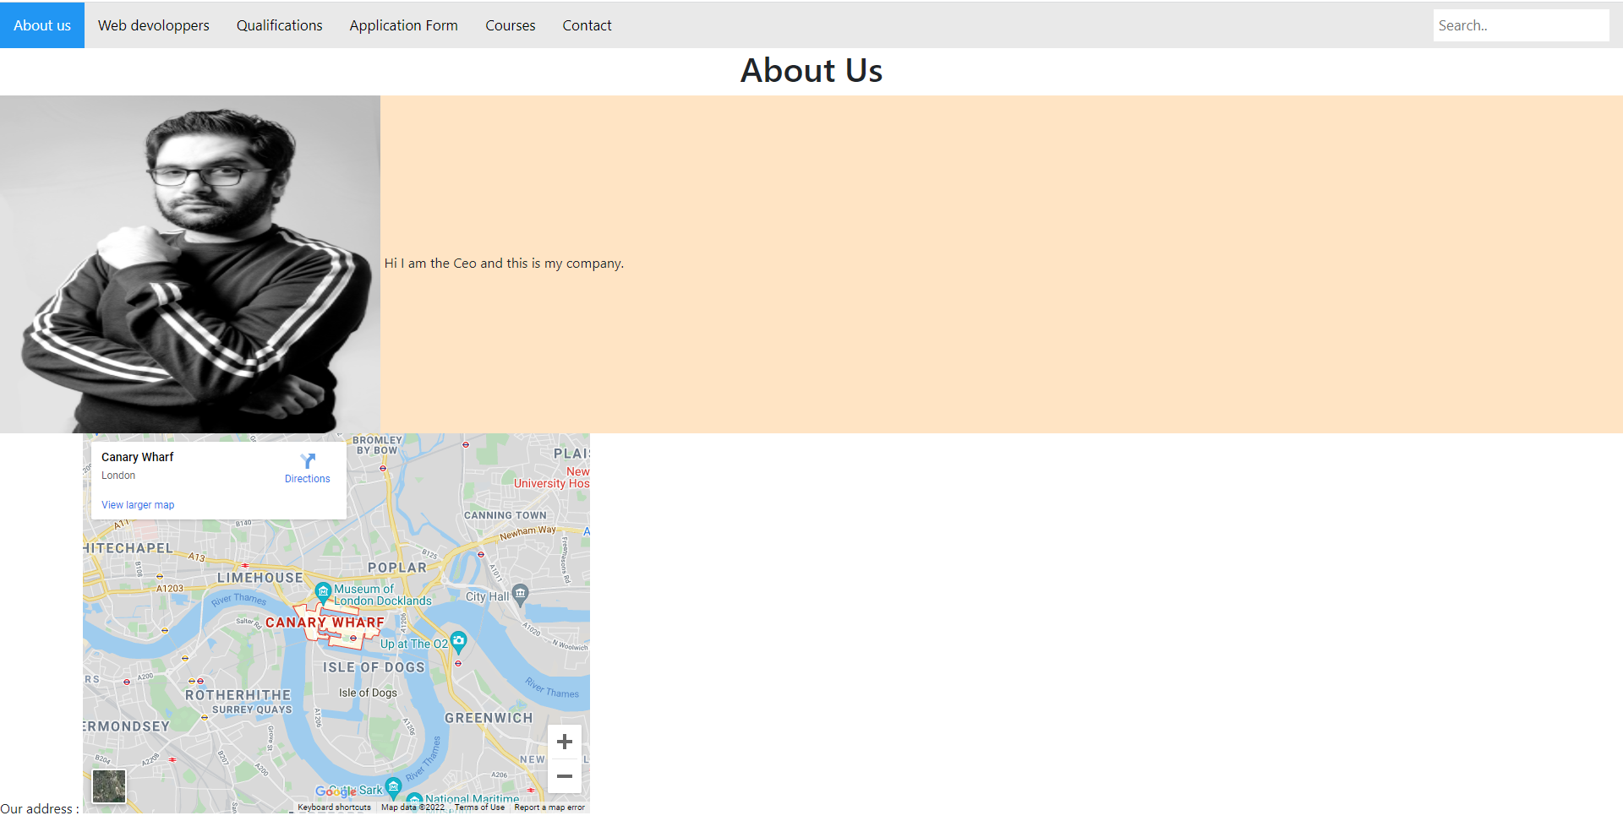

**Before improvement: courses page**

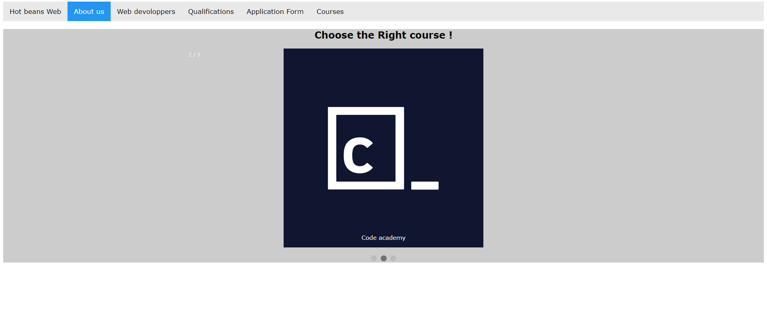

No hyperlink

Only image

No description

Qulification before improvement

